Work |  | Reviewer
Name, Surname | Syed Yasoob Raza Naqvi | Name, Surname | Marwan Ahmed
Matriculation number | 7226703 | Matriculation number | 7226233
Group in course N | 25

Please answer following questions. First put the code from the solution, then rate each question 1-5 (1=Poor, 3=Adequate, 5=Excellent) and provide specific feedback on the code implementation.
Include examples where possible.

How was implemented csv reading & dataframe creation
Put original code here:
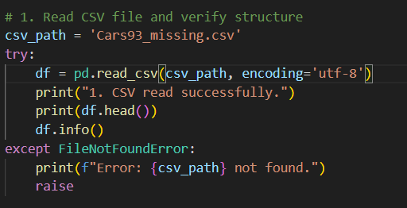

Was the CSV file read correctly into a DataFrame? (e.g., pd.read_csv()  used properly) | 5 – Correct – pd.read_csv(csv_path, encoding='utf-8') loads Cars93_missing.csv into a DataFrame without issues.
Were encoding issues or path errors handled? (e.g., encoding='utf-8'  specified) | 4 – FileNotFoundError is caught and reported, and UTF-8 is set, but there is no fallback for other encodings (e.g., except UnicodeDecodeError: read again with encoding='latin-1').
Was the DataFrame structure verified (e.g., .head(), .info() used)? | 5 – Structure is checked with df.head() and df.info() right after loading.

How was implemented object-to-index conversion & conditional data changes
Put original code here:
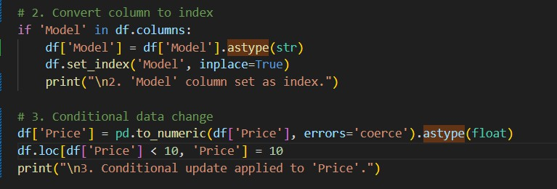

Was an object/string column correctly converted to an index? (e.g.,  df.set_index('column')) | 5 – 'Model' is cast with astype(str) and set with set_index('Model', inplace=True), guarded by an if 'Model' in df.columns check.
Did conditional changes use vectorized operations (e.g., df.loc[df['col'] > 5,  'col'] = new_value)? | 5 – Fully vectorized: df.loc[df['Price'] < 10, 'Price'] = 10 – no loops.
Were edge cases (e.g., mixed data types) handled? (e.g., astype() or error handling) | 4 – pd.to_numeric(errors='coerce') handles mixed types, but only for 'Price', and the number of values turned into NaN is not reported.

How was implemented missing values & column statistics
Put original code here:
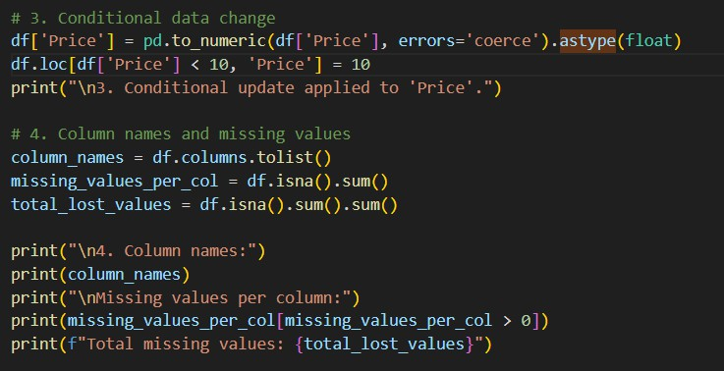

Was missing value detection accurate? (e.g., df.isna().sum()) | 5 – Accurate – df.isna().sum() per column, a filter for columns with gaps, and a grand total with .sum().sum().
Were column names retrieved correctly? (e.g., df.columns.tolist()) | 5 – Retrieved correctly with df.columns.tolist().
Was the code efficient for large datasets? (e.g., avoided loops) | 5 – All operations are vectorized pandas calls with no Python loops, so it scales to large datasets.

Was in the code implemented column swapping, sorting & trimming ?
Put original code here:

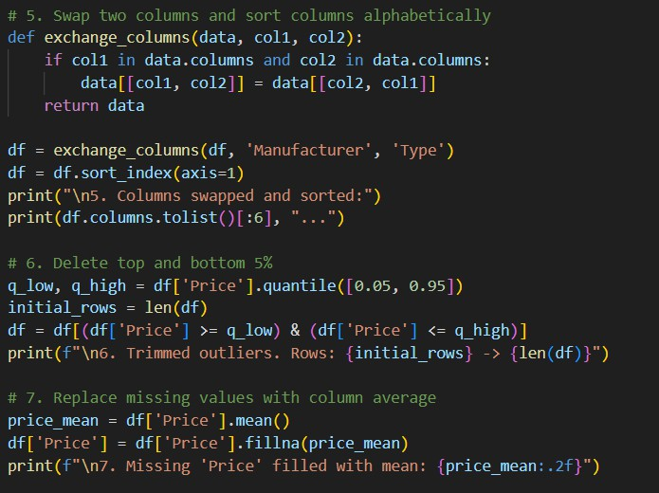

Was column swapping implemented correctly? (e.g., df[['col1', 'col2']] = df[['col2',  'col1']]) | 4 – data[[col1, col2]] = data[[col2, col1]] swaps the values but keeps the headers, so 'Manufacturer' now holds Type data and vice versa. The sort_index(axis=1) that follows also undoes any positional swap.
Was sorting by name done efficiently? (e.g., df.sort_index(axis=1)) | 5 – Efficient – df.sort_index(axis=1) sorts the columns alphabetically in one call.
Was trimming (top/bottom 5%) accurate? (e.g., df.quantile([0.05, 0.95])) | 4 – quantile([0.05, 0.95]) bounds are correct, but the filter also drops rows with missing Price, so the later fillna(mean) has nothing to fill. Fill before trimming or keep NaN rows.

How was done visualization and analysis
Put original code here:

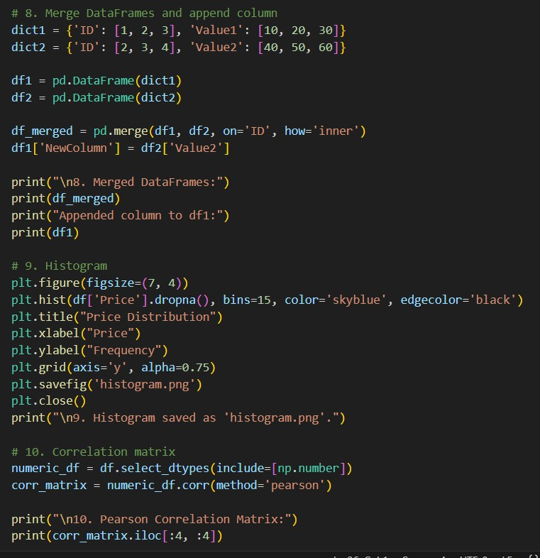

Was the histogram created with proper labels? (e.g., plt.hist(df['col']) + plt.xlabel()) | 5 – Well labelled: title, xlabel, ylabel and grid, with bins=15 on df['Price'].dropna().
Was the correlation matrix calculated correctly? (e.g., df.corr(method='pearson')) | 5 – Correct – select_dtypes(include=[np.number]).corr(method='pearson'). Only a 4×4 slice is printed.
Were visualizations saved/exported? (e.g., plt.savefig('hist.png')) | 4 – The histogram is saved with plt.savefig('histogram.png'), but the correlation matrix is not plotted or exported (e.g., as a heatmap saved to correlation.png).

What is your opinion:
[⬛ ] Work was done individually
[] work was done with the help of generative AI

